**LSP-LRS-0825F**

**Laser Range Finder Module**

**Technical Specification**

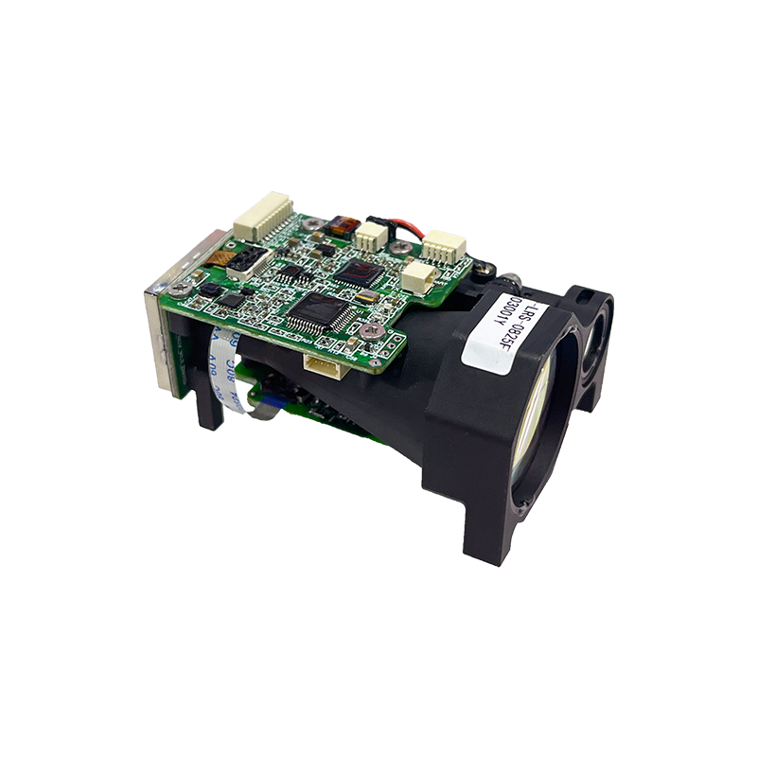



**Ver 2025.3**

1. Overview

The LSP-LRS-0825F laser rangefinder module is developed based on our self-designed 1535nm erbium laser. It adopts a single-pulse TOF (Time-of-Flight) ranging method, with a maximum measurement range of ≥8km. The module consists of the laser, transmission optical system, receiving optical system, and control circuit board. It communicates with the host computer via RS422 serial port and provides test software and communication protocols for easy secondary development by users. The module features small size, light weight, stable performance, high impact resistance, and is Class 1 eye-safe.

1. Structural Composition and Main Performance Indicators

The LSP-LRS-0825F laser rangefinder consists of a laser, a transmitting optical system, a receiving optical system and a control circuit. The main performance is as follows:

**2.1 Ranging Capacity**

Visibility under the conditions of visibility is not low 20km, humidity ≤80%, for large targets (buildings) ranging distance ≥10km; For vehicles (2.3m×2.3m target, diffuse reflectance ≥0.3) ranging distance ≥8km; For personnel (1.75m×0.5m target) ranging distance ≥4km.

**2.2 Main functions**

a) single ranging and continuous ranging;

b) Range strobe, front and rear target indication;

c) Self-test function.

**2.3 Performance**

a. Wavelength: 1535nm±5nm;

b. Laser divergence Angle: ≤0.3mrad;

c. Continuous ranging frequency: 1~10Hz adjustable;

d. Ranging accuracy: ≤±1m;

e. Accuracy: ≥98%;

f. Minimum measuring range: ≤30m;

g. Ranging resolution: ≤30m;

h. Power supply voltage: DC5V ~ 28V;

i. Weight: < 75g;

j. Power consumption: standby power consumption ≤150mW, average power consumption ≤3W, peak power consumption ≤7W;

k. Size: ≤65×46×32mm;

**2.4 Environment Adaptability**

a. Operating temperature: -40℃ ~ +60℃;

b. Storage temperature: -55℃ ~ +70℃;

c. Impact: 75g@11ms;

d. Vibration: Vibration environment of combined wheel vehicles.

**2.4 Interface**

Communication interface: RS422, 115200bps

Electrical interface: The interface model is A1002WR-S-10P, and the interface definition is detailed in the following table.

|  |  |  |
| --- | --- | --- |
| **Wire No** | **Definition** | **Remarks** |
| 1 | VIN+ | Power supply + |
| 2 | VIN- | Power supply - |
| 3 | POWER_EN | Module power supply enabled, TTL_3.3V level;  Module on (> 2.7V or suspended)  Module off (< 0.3) |
| 4 | RS422 TX+ | RS422 receive + |
| 5 | RS422 TX-(UART_TXD) | RS422 Reception –  (UART serial port transmission, TTL3.3V level) |
| 6 | RS422 RX-(UART_RXD) | RS422 transmission –  (UART serial port reception, TTL3.3V level) |
| 7 | RS422 RX+ | RS422 transmit + |
| 8 | Reserved |  |
| 9 | Reserved |  |
| 10 | GND | Communication earthing |

**2.5 Mounting drawing**

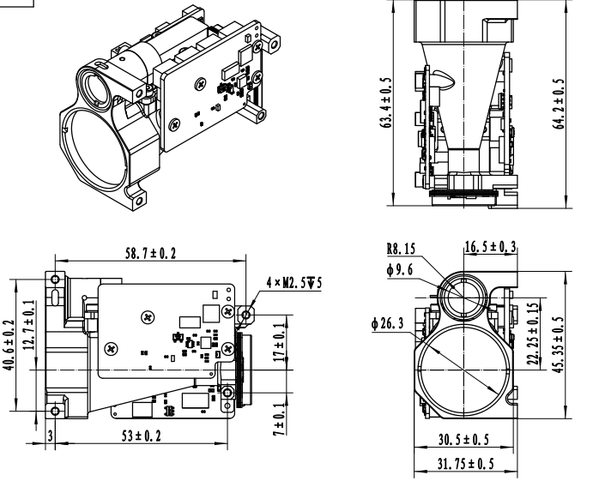

1. User Precautions

* The laser emitted by this rangefinder is 1535nm, which is safe for human eyes. Although it is an eye-safe wavelength, it is advised not to look directly into the laser.
* When adjusting the parallelism of the optical axis, be sure to cover the receiving lens to avoid permanent damage to the detector due to excessively strong echoes.
* This rangefinder module is not airtight. Ensure that the relative humidity of the environment is below 80% and maintain a clean and sanitary environment to prevent damage to the laser.
* The range of the rangefinder is related to atmospheric visibility and the nature of the target. Range will be reduced in fog, rain, and sandstorms. Targets like green tree clusters, white walls, and exposed limestone have better reflectivity and can increase range. Additionally, increasing the angle of the laser beam to the target will reduce the range.
* Do not emit lasers at highly reflective targets such as glass or white walls within 30 meters to avoid echo overstrength and damage to the APD detector.
* Do not plug or unplug cables while the device is powered on.
* Ensure the correct polarity of the power supply connection to avoid permanent damage to the equipment.